Ansible Configuration Steps

Step1: First you required 1 controller node and n host node (host node could be multiple)
In this case we have 1 Controller Node and 2 Host node

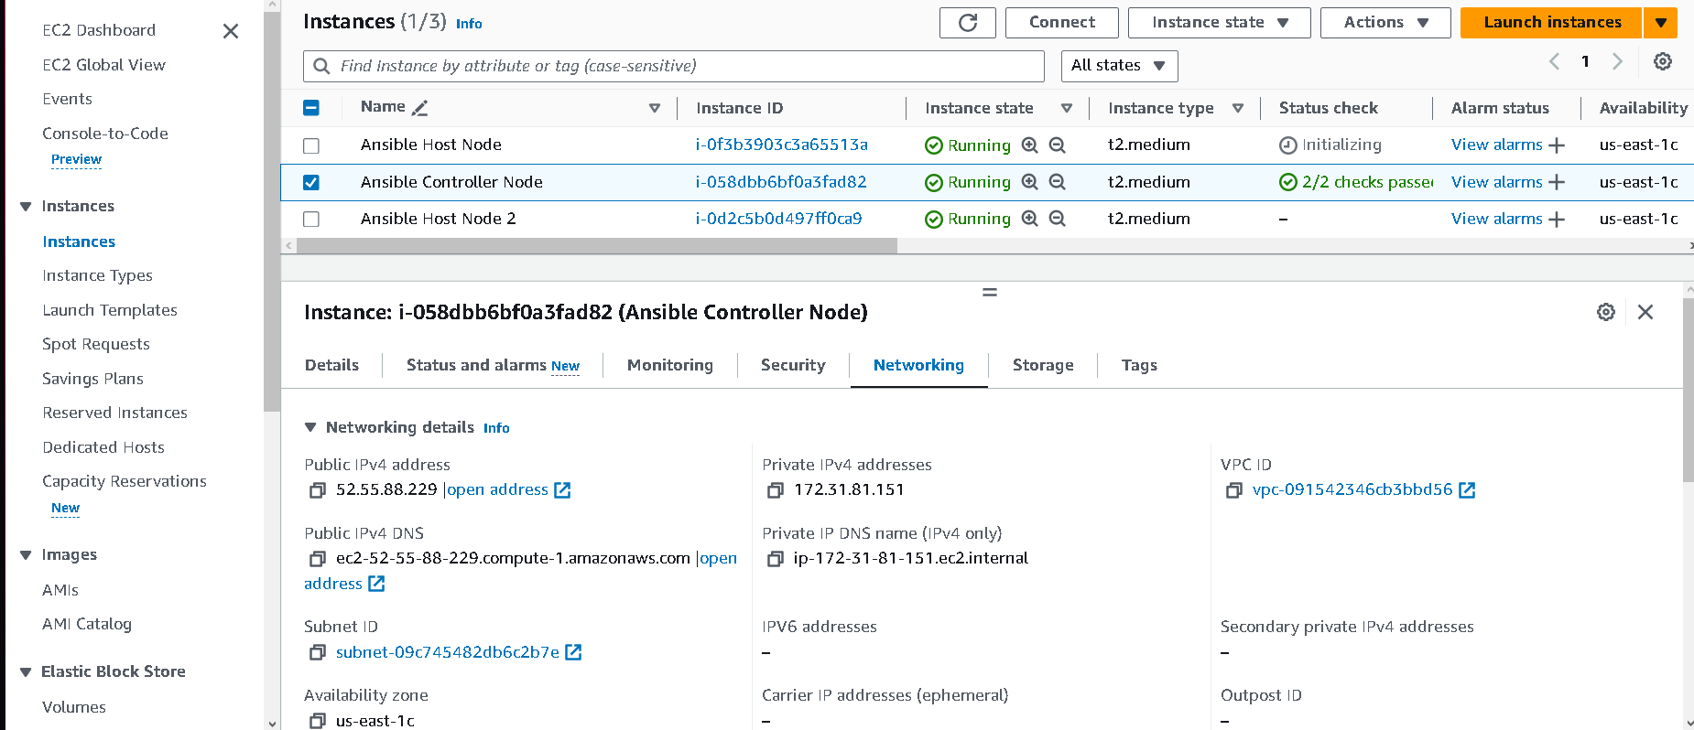

Step2: Open Ansible Controller Node ec2 instance and install ansible here only
$ sudo apt update
$ sudo apt install software-properties-common
$ sudo add-apt-repository --yes --update ppa:ansible/ansible
$ sudo apt install ansible

Step 3: Now navigate to Ansible folder and open hosts file for host node Confg
cd /etc/ansible
sudo vi hosts

Step 4: now create a group SL i.e Simple Learn you could use anything and mentioned private Ip of your host node
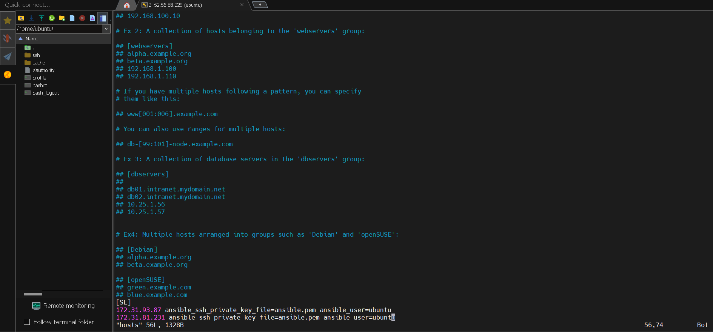

Step 5: We also required .pem file which is used for creating host nodes and controller node
(i) now need to copy .pem key from local machine to our ec2 instance vm server
(ii)now navigate to folder where .pem key is present and open gitbash termical from that folder and enter below cmd
scp -i ansible.pem ./ansible.pem ubuntu@52.55.88.229:/home/ubuntu

scp -i ansible.pem // this will help to authenticate
O/P
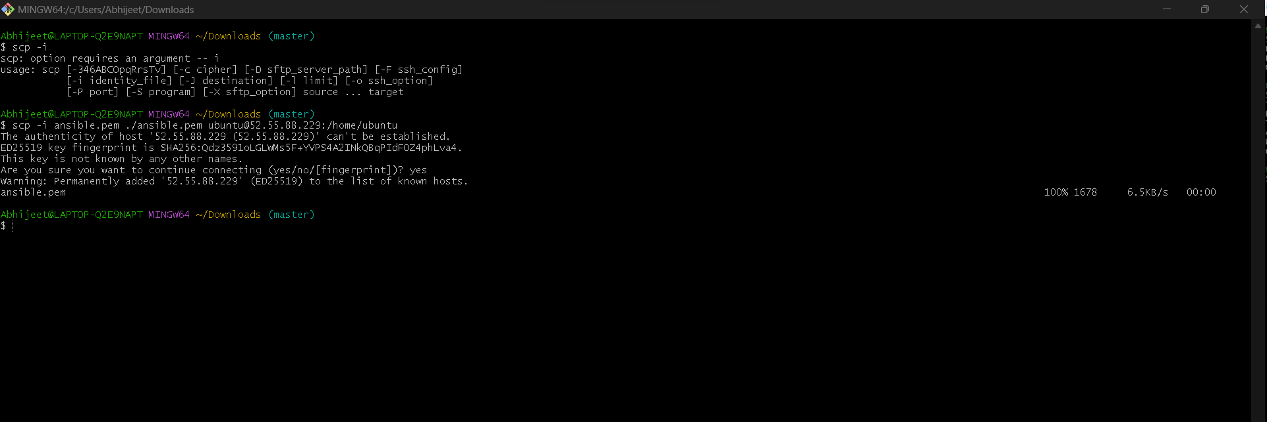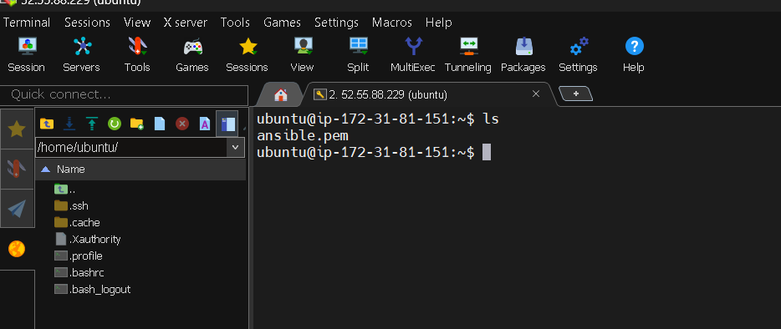
Now check the mode of this file i.e ansible.pem using below command
$ls –la
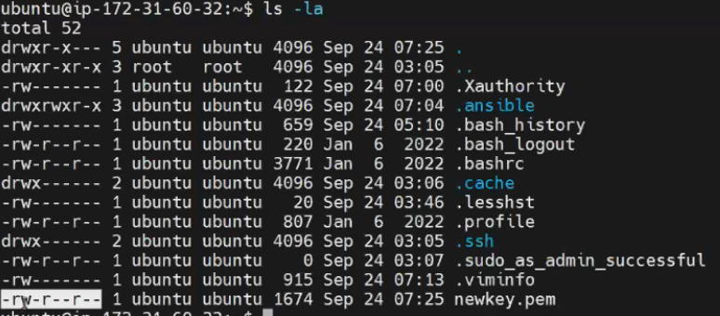

Now change the mod to readwrite only using below command
$ chmod 600 ansible.pem
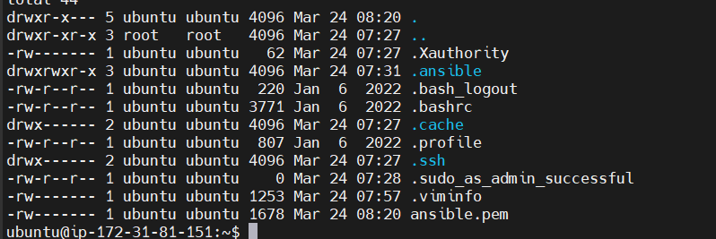

Now edit the host file using below commad and add the key path
sudo vi /etc/ansible/hosts
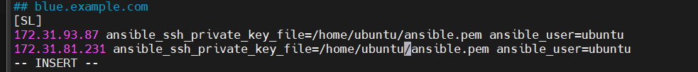
In this way we can authenticate host node using private key i.e .pem file
Step 6: Check everything is perfect using this ping command
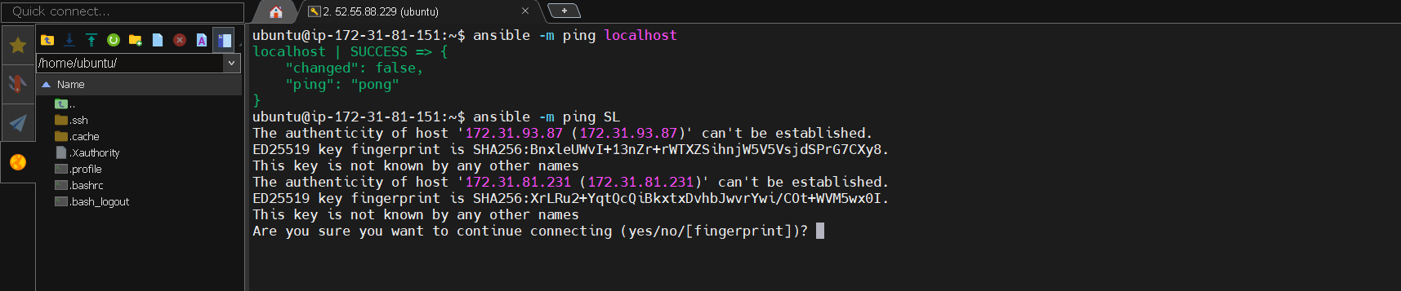

I got error message that is host nodes unreachable
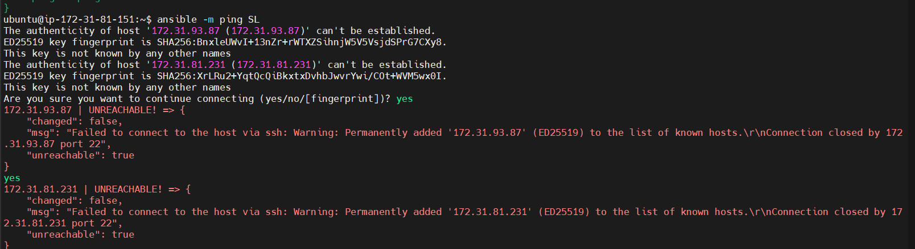

To fix this go to security groups and and edit inbound rule custom_tcp and source my Ip
Note: after adding this cmd ansible -m ping SL make sure type 2 times yes
O/P
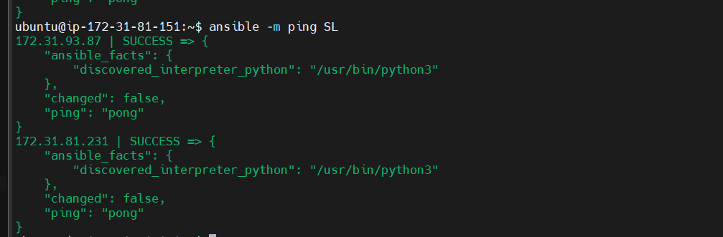

Now you will be able to connect from controller node to these two host nodes

Step 7: Now using Some adhoc commad we will create file in host server
ansible SL -a "touch abhijeet"
Successfully created two file on host nodes
O/P
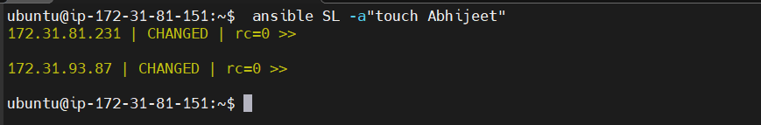
File Abhijeet Created on host node
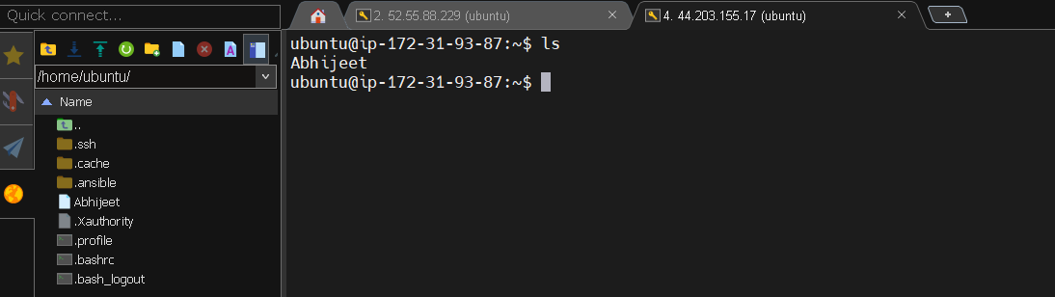

Bonus Part
We can also declare our hosts in Inventory like this
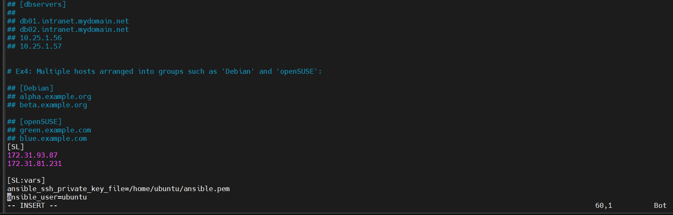
Adhoc commad syntax
$ ansible [pattern] –m [module] –a “[module options]”
You can now also install Docker in hosted nodes
ansible SL -a"sudo apt update -y"
ansible SL -a"sudo apt install docker.io -y"
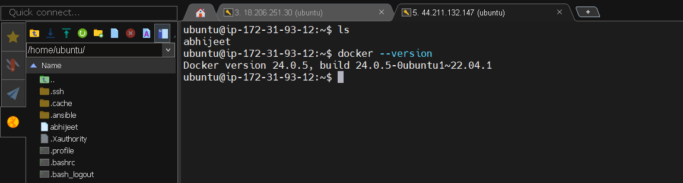
Now we will do adhoc commad with module
ansible SL -m apt -a"name=nginx state=present" –b
check the status of nginx service
ansible SL -m command -a "systemctl status nginx" –b

------------------------- Now see some example of Ansible Play Books ---------------------------
First make directory of ansibleplaybook
mkdir ansibleplaybook
create playbook yaml file
vi firstplaybook.yaml
---
- hosts: SL
user: ec2-user
become: yes
connection: ssh
tasks:
- name: install docker
action: apt name=docker state=present

To run Ansible playbook use following Command
Ansible-playbook firstplaybook.yaml
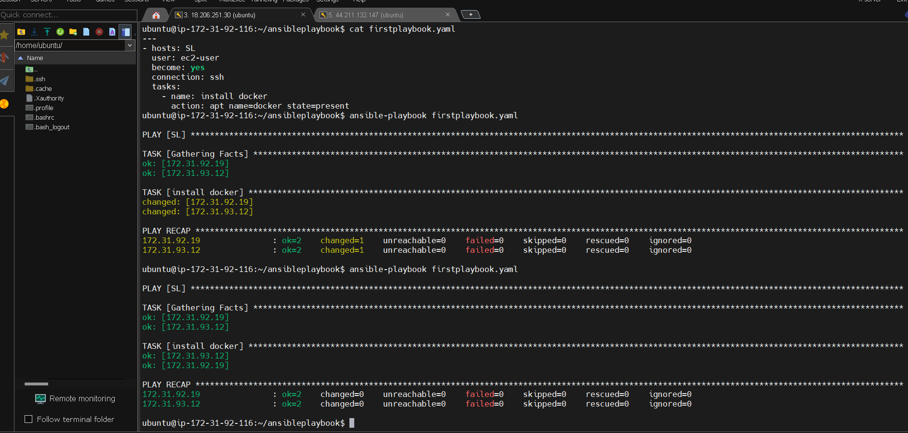

You Can also define multiple tasks
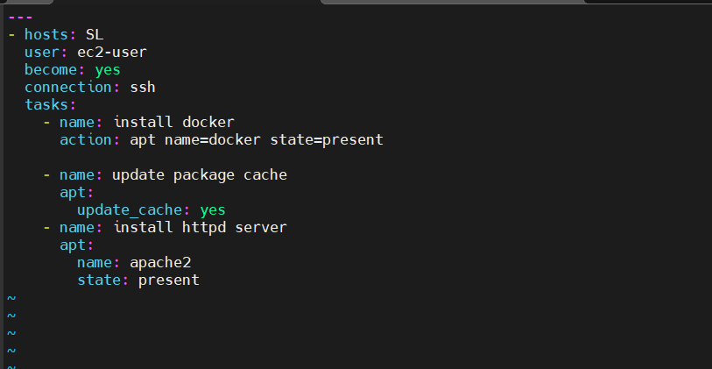

O/p:
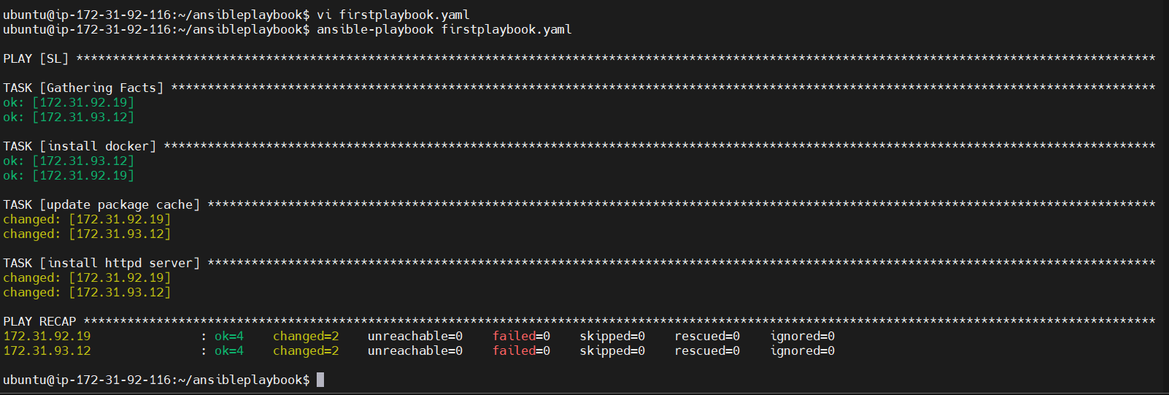

Lets take One more example Uninstall the Docker and Install Maven using Ansible Playbook

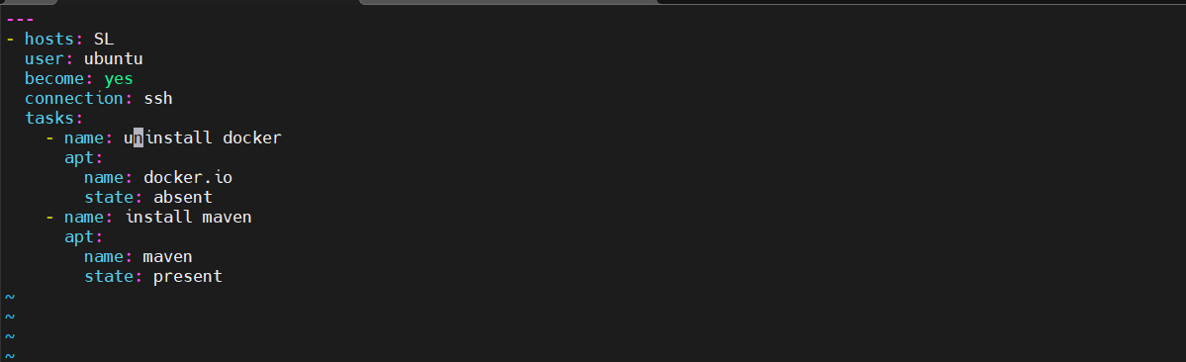

O/p
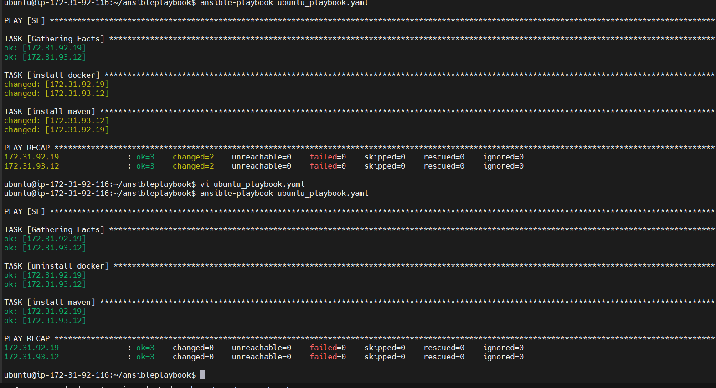
Next example is for handler means host html file on apache server in Ubuntu
vi handlerplaybook.yaml
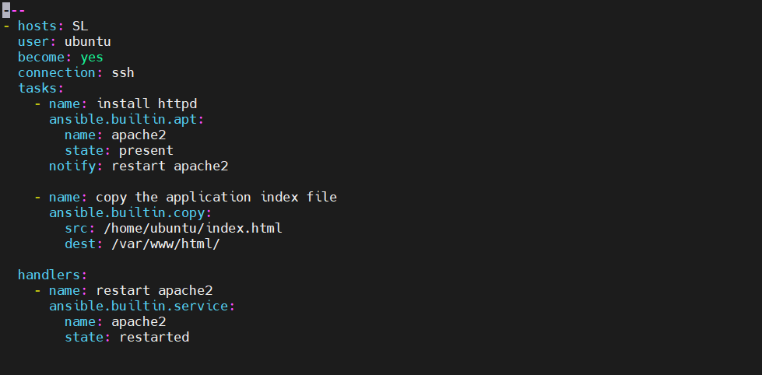

Now run the ansible playbook
$ ansible-playbook handlerplaybook.yaml
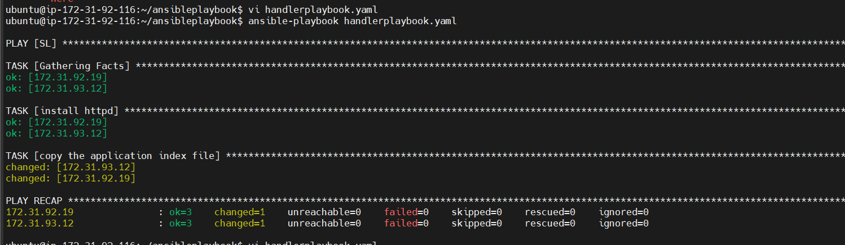

Now you che verify that in host ect2 instance our index.html file is hosted
Open your browser and paste your public ip along with port 80 becase apache2 by- default run on port 80
http://44.211.132.147:80
o/p:


You can also check in hosted nodes that index.html file is uploaded in /var/ww/html/ directory
o/p:


Note this script also work but above script was better to view
vi handlerplaybook.yaml
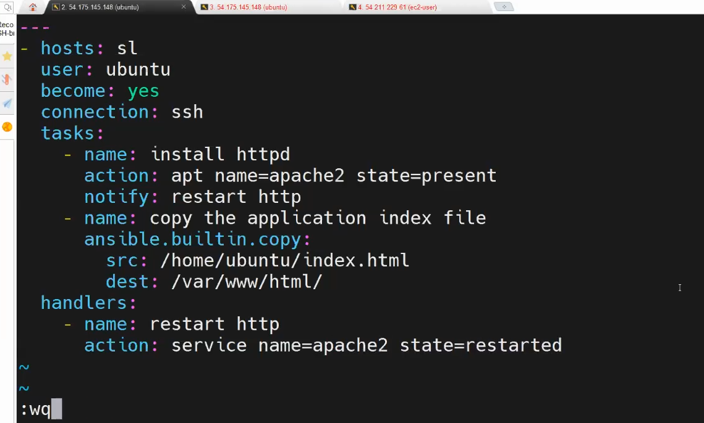

Attension don’t forget to edit security services
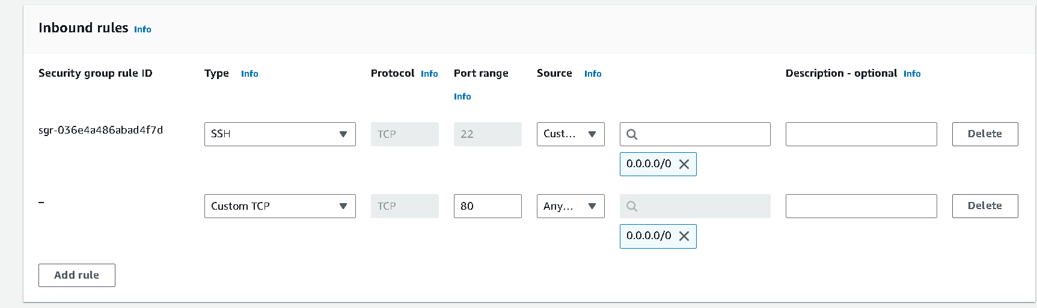

--------------------Lets see how to create roles in Ansible----------------------
What is Ansible roles?
Ans: Ansible Roles provide a structured way to organize tasks, templates, files, and variables. This structure makes it easier to manage complex automation setups, as everything related to a specific role is contained within its directory.

Where to locate roles directory in ansible
$ cd /etc/ansible/roles

Refer roles for documentation from this website
https://galaxy.ansible.com/ui/

crete ansible demo-role
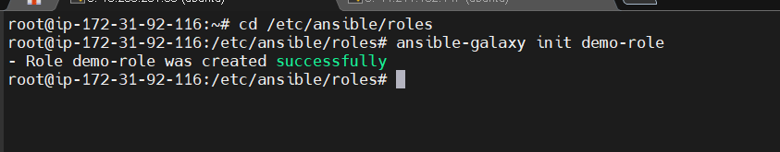

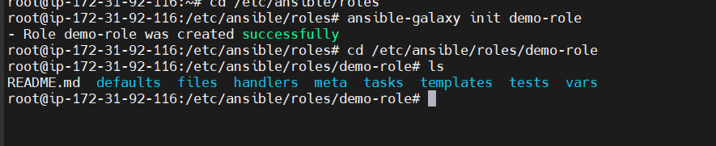

What is the purpose of each directory
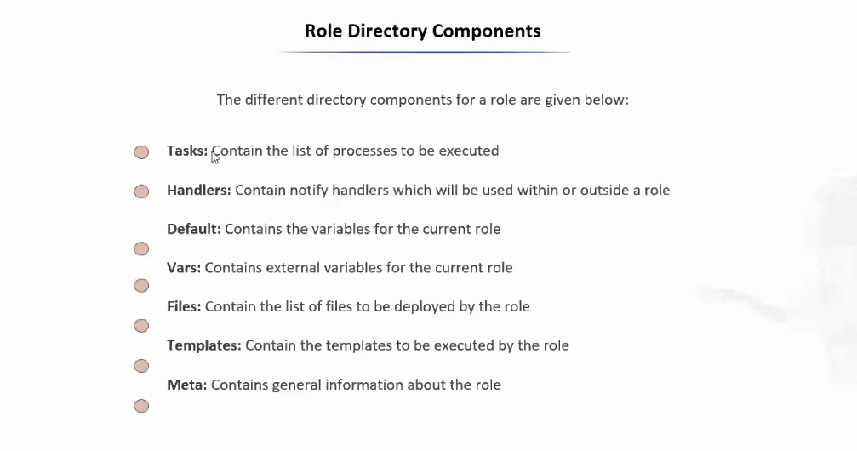
------- Lets host the de-role in nginx server -------
cd /etc/ansible/roles/demo-roles/tasks
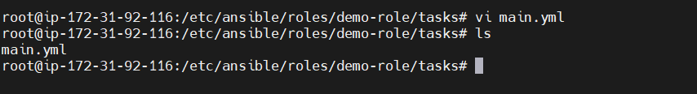

then in tasks folder there is main.yml file modify it
vi main.yml
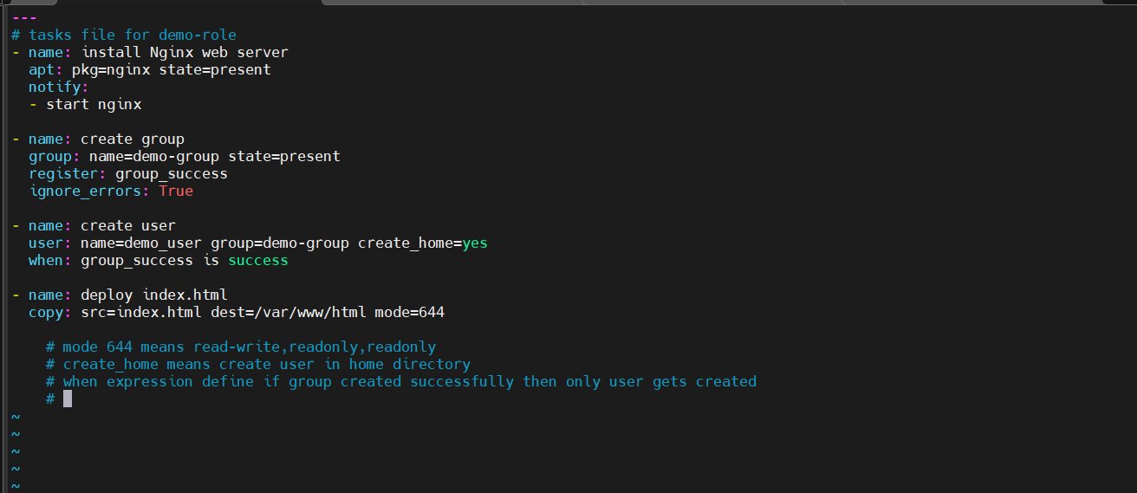

Now change directory to /etc/ansible/roles/demo-role/files#
Create index.html
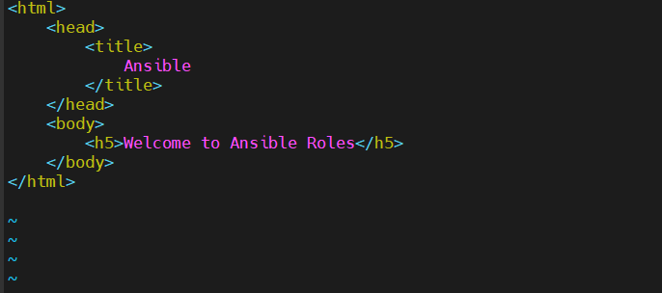
We are done with files folder and tasks folder
Now navigate to handler folder
cd /etc/ansible/roles/demo-role/handlers
do some changes in main.yml
vi main.yml
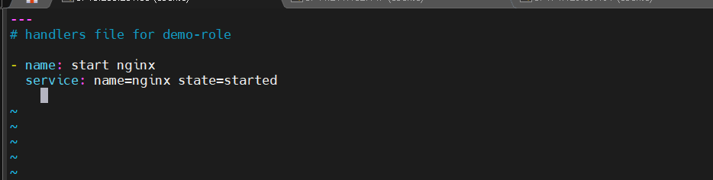

Basically what we have done here
Created index.html file in demo-role/files
Modified main.yml file in demo-role/handlers
Define task in demo-role/tasks

Now final step is apply this created role i.e demo-role

Create nginx role for apply these
First navigate back to roles folder and create nginx.yml file
vi nginx.yml
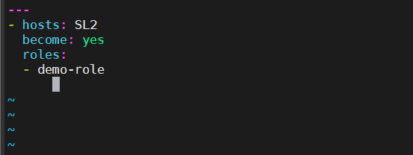
Now dublicate the current tab and add private ip in i.e Ansible host node 3
inside hosts file

create a new group
vi /etc/ansible/hosts

o/p
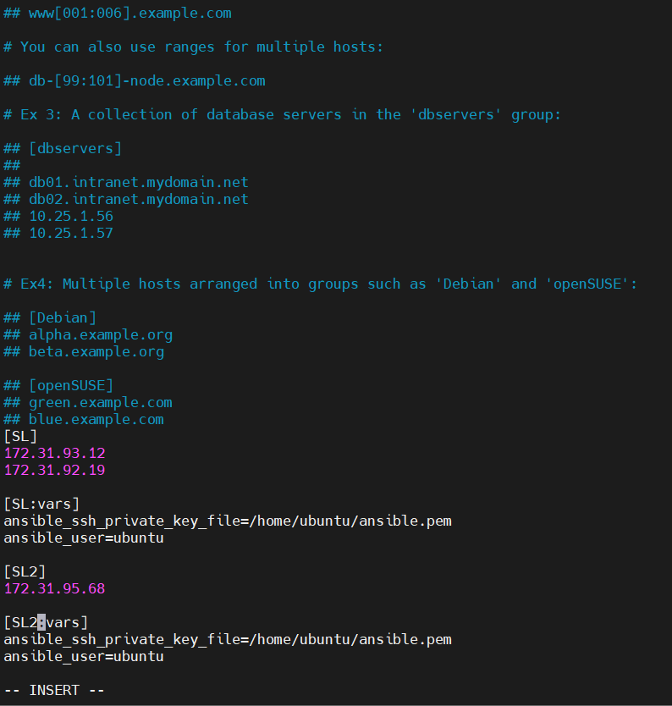

Check to verify the ping newly created vm is connected or not i.e Ansible hostnode 3

$ ansible –m ping SL2

o/p
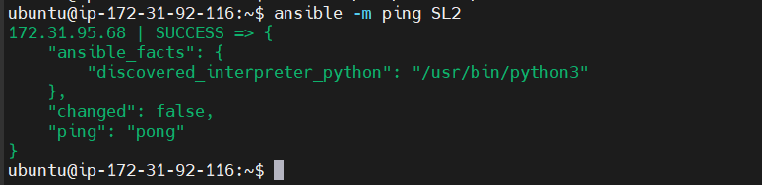

Now run nignx playbook roles
$ ansible-playbook nginx.yml
o/p
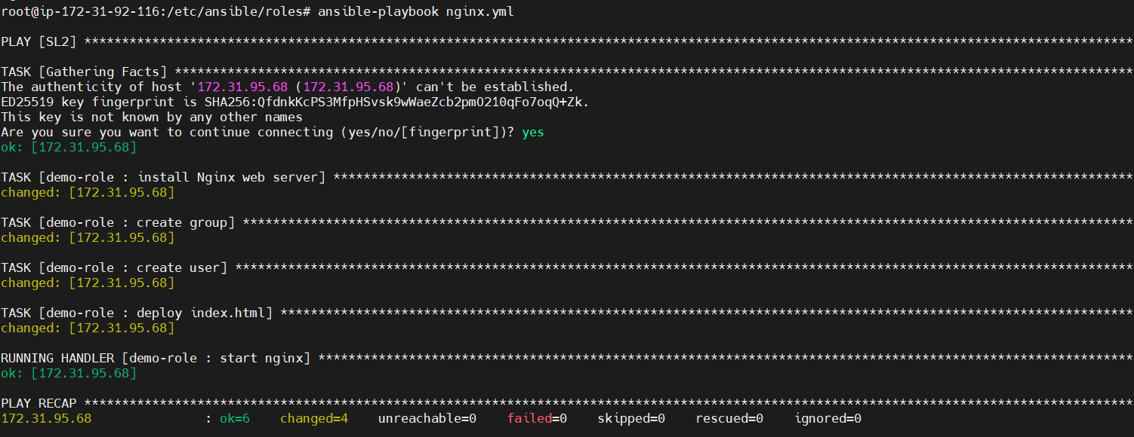

If you get any error while installing nginx then using adhoc command update the package first
$ ansible SL2 –a”apt update -y” –b
Note : only use above command if you get any error then again run playbook file

Finally to test above execution copy public ip of new created vm and paste it on web browser
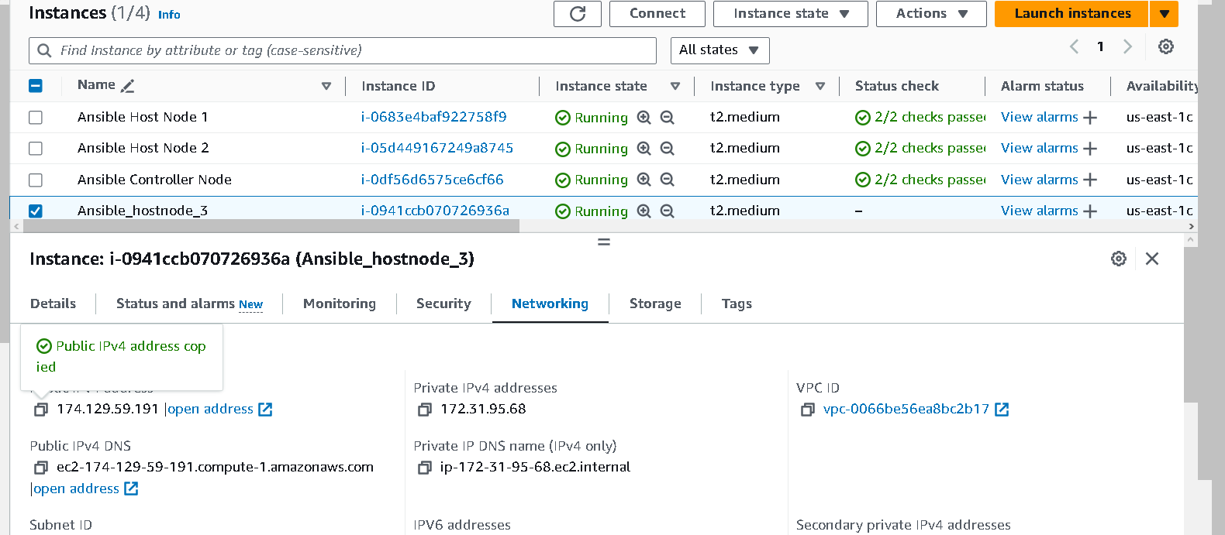

Final output
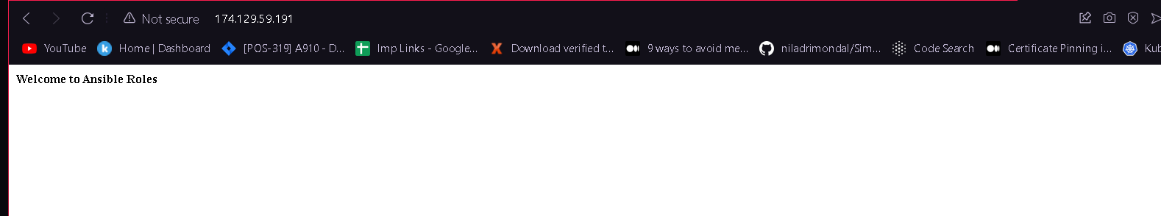

If its how showing or getting dns error then check security group

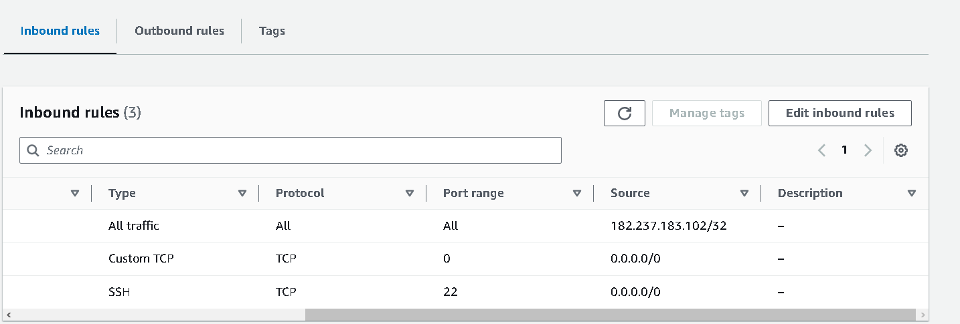

Above output is not fully correct because some syntax in wrong in index.html file
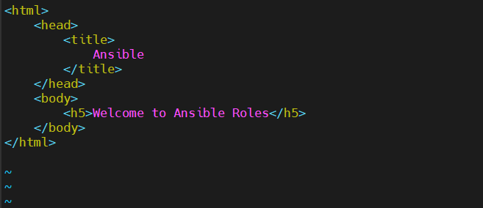

Now its correct
